Windows Fundamental

* OS version defined for Windows 8.1 was 6.3.
* Kernel-
* Bridge between application and hardware
* Operations – Thread scheduling, Routing hardware interrupts
* Application run in user mode whereas core OS components run in kernel mode.
* Drivers may run in kernel mode or in user mode

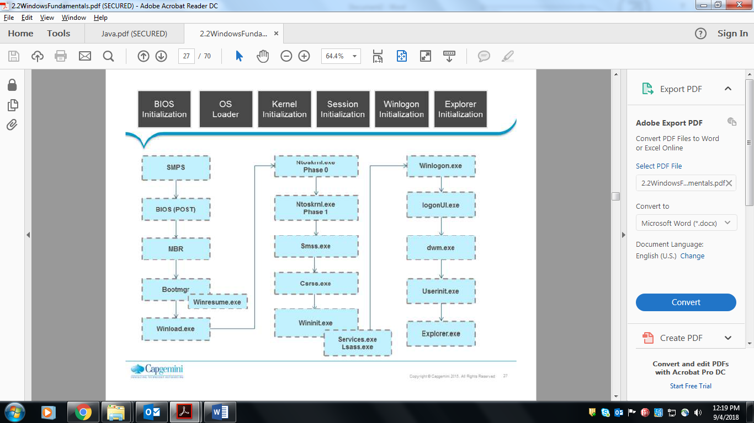

* Safe boot –
* In safe boot we have access of basic files and drivers (mouse , monitor, keyboard, mass storage , default system services)
* Help us to diagnose problem
* Safe mode (SAFEBOOT_OPTION=Minimal)
* Safe mode with networking (SAFEBOOT_OPTION=NETWORK)
* Safe mode with command prompt (SAFEBOOTOPTION=Minimal(Alternate shell))
* File system-
* FAT (File Allocation Table)

Version-

1. FAT 12,
2. FAT 16
3. FAT 32
4. exFAT

* NTSF (New Technology File System)

1. NTFS v1.0
2. NTFS v3.0
3. NTFS v3.1

GPT (GUID Partition Table) –

* first introduced as a part of Extensible Firmware Interface (EFI) initiate from Intel.
* Used to boot system when UEFI (Unified Extensible Firmware Interface) boot is supported, otherwise MBR is used
* Allows 128 primary partition

Service Control manager –

* Administration should use snap-in or sc.exe command line tool to query or configure services.

Windows Management Instrumentation (**WMI**)- To satisfy Windows Driver Manager (WDM) requirements.

Process is defined by –

1. Address Spaces
2. Resources (handles)
3. Security profile (token)

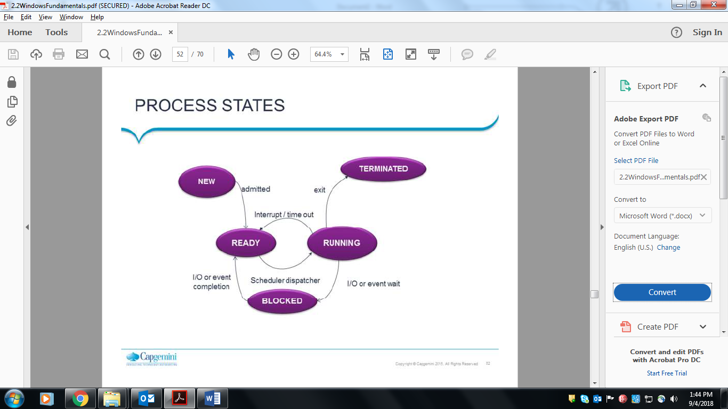

Processes terminate either voluntarily through an exit system call or involuntarily as the result of a signal.

Memory pool-

* Paged pool
* Non-paged pool

Page fault –

* Hard page fault
* Soft page fault
* Demand-zero fault

Page files -The page file, also known as the swap file, pagefile, or paging file, is a file on your hard drive. It’s located at C:\pagefile.sys by default, but you won’t see it unless you tell Windows Explorer not to hide protected operating system files.

Linux Fundamentals

Software-

* Freeware (free with limited features)
* Shareware (free for limited time)
* Commercial (full/partial feature on cost)
* Open source (free/cost with source code)

Open source licenses-

* ALS 2.0
* GNU GPL 3.0
* MIT

Flavors of UNIX –

* HP-UX
* IBM-AIX
* SUN-SOLARIS

Flavors of LINUX (clone of unix)–

* Ubuntu
* Fedora
* Linux Mint
* openSUSE
* PCLinuxOS
* KNOPPIX

MINIX was created by Andrew in 1987.

LINUX was developed during GNU project.

API - An application program interface (**API**) is a set of routines, protocols, and tools for building software applications.